Tema 4 Grundlæggende UX

I tema 4 har jeg lært om

:Survey

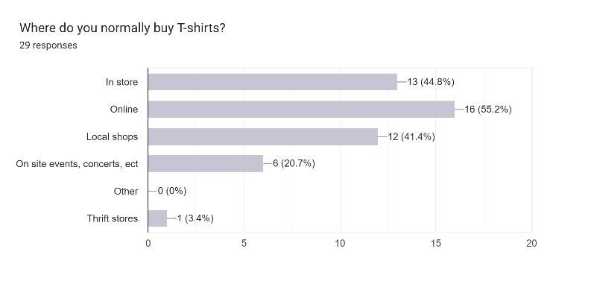

:Interview

:Design patterns

Inspiration til hvordan man selv kan gribe et design.

<https://ui-patterns.com/patterns>

:Design Sprint Sketch

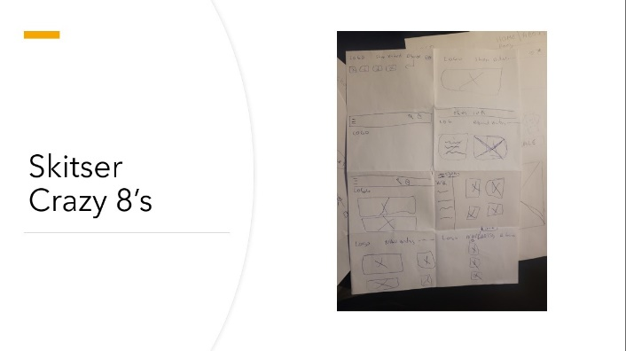

:Design Solution Sketch

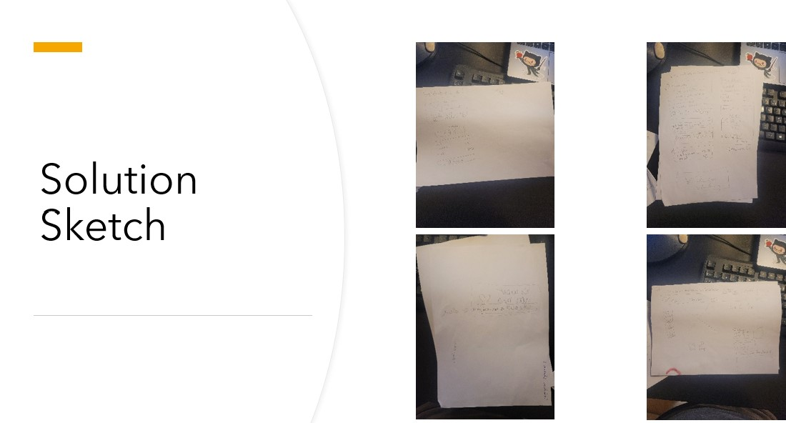

:User test

:StyleTile

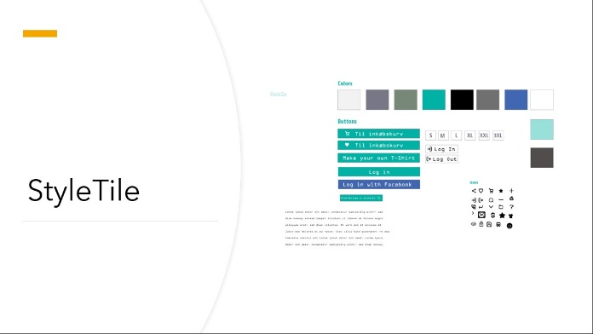

:Desk Præsentation

